Project Design Phase
Solution Architecture

Date | 24 February 2026
Team ID | LTVIP2026TMIDS42582
Project Name | Home-Rentals
Maximum Marks | 4 Marks

Solution Architecture:
Overview:
The solution architecture bridges the gap between the business need for a reliable, scalable home rentals platform and the technology required to deliver it. It ensures that all stakeholders understand the system’s structure, features, and development roadmap.
Goals:
- Identify and implement the best technology stack to address the challenges of property search, booking, payment, and communication between renters and hosts.
- Clearly describe the system’s structure, components, and interactions to all project stakeholders.
- Define core features (user registration, property listing, search, booking, payment, messaging), development phases (MVP, feature expansion, scaling), and solution requirements (security, performance, usability).
- Provide detailed specifications for each component, including APIs, data models, integration points, and deployment strategies.
Key Elements:
- Architecture Structure:
  - Multi-tier architecture: Presentation (React.js web/mobile app), Application (Node.js/Express backend), Data (MongoDB Atlas cloud database).
  - Microservices for payment, notifications, and recommendation engine.
  - RESTful APIs for communication between client and server.
  - Integration with third-party services (payment gateway, email/SMS, cloud storage).

Example - Solution Architecture Diagram:

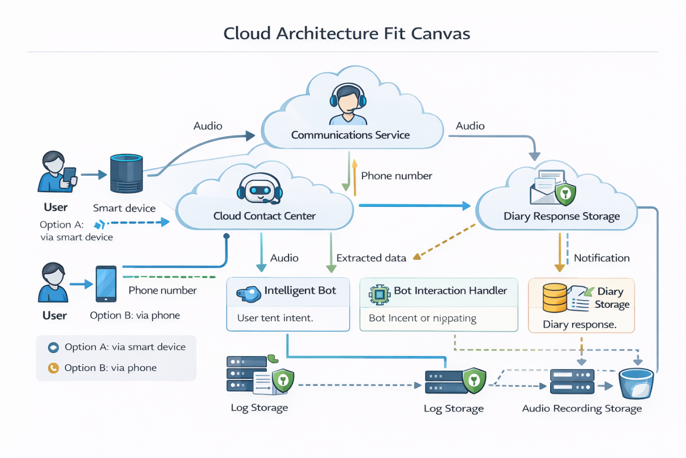
Figure 1: Architecture and data flow of the Home-Rentals Application
Reference: https://aws.amazon.com/blogs/industries/voice-applications-in-clinical-research-powered-by-ai-on-aws-part-1-architecture-and-design-considerations/

